

**UNIVERSITY OF PETROLEUM & ENERGY STUDIES**

**College of Engineering Studies Dehradun**

**LAB FILE**

**Experiment 7**

Programme : B. Tech in Computer Science and Engineering with Specialization in DevOps

Course : Continuous Integration & Continuous Deployment Lab

No. of credits : 1

Semester : V

Session : July-December 2020

Batch : 2018-2022

Faculty : Dr. Hitesh Kumar Sharma

Submitted By:

Ingit Singhal

Sap id: 50056426

Roll No : R171218048

**Lab Experiment 7**

**Creating Pipeline using Blue Ocean Plugin**

**Screenshots**

**1. Download Blue Ocean plugin from Manage Plugins in Jenkins. This is how the Blue Ocean Window appears.**

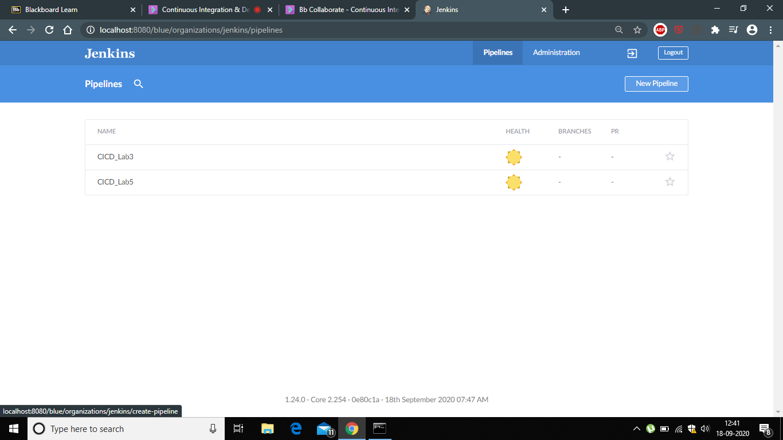

**2. Click on the New Pipeline option.**

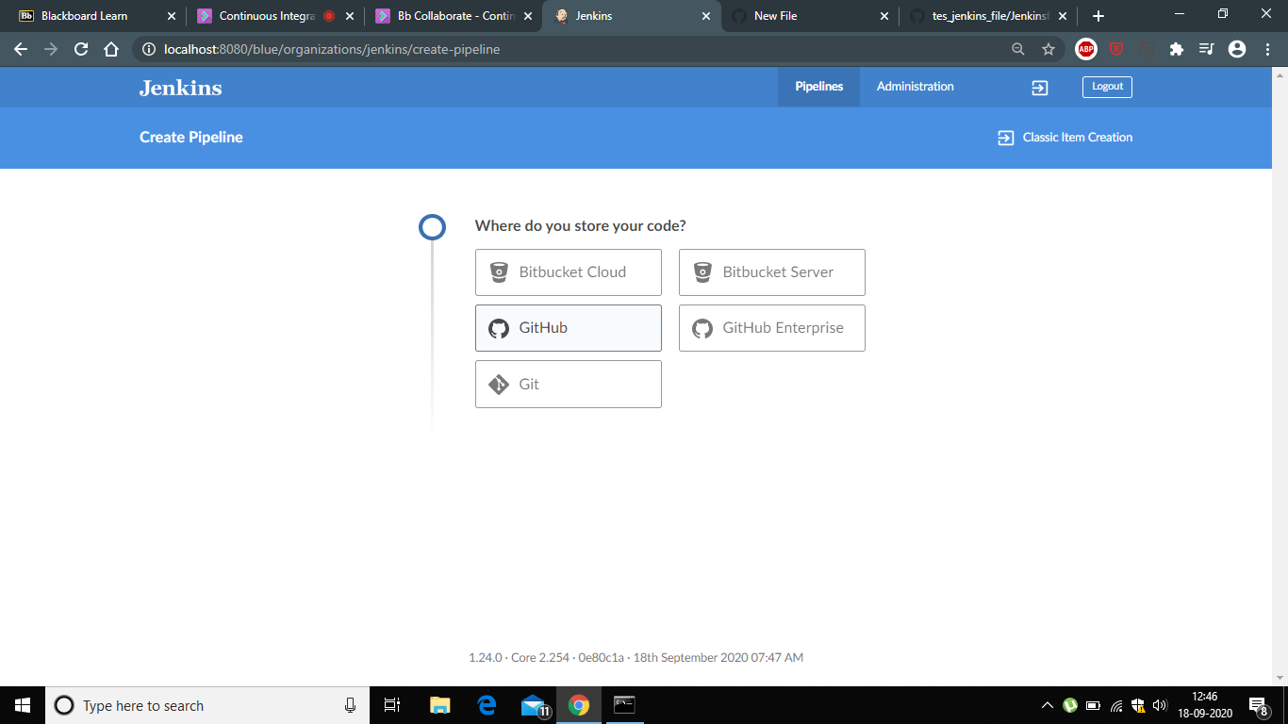

**3. Make a new repository on Github and include pom.xml file mainly a maven project.**

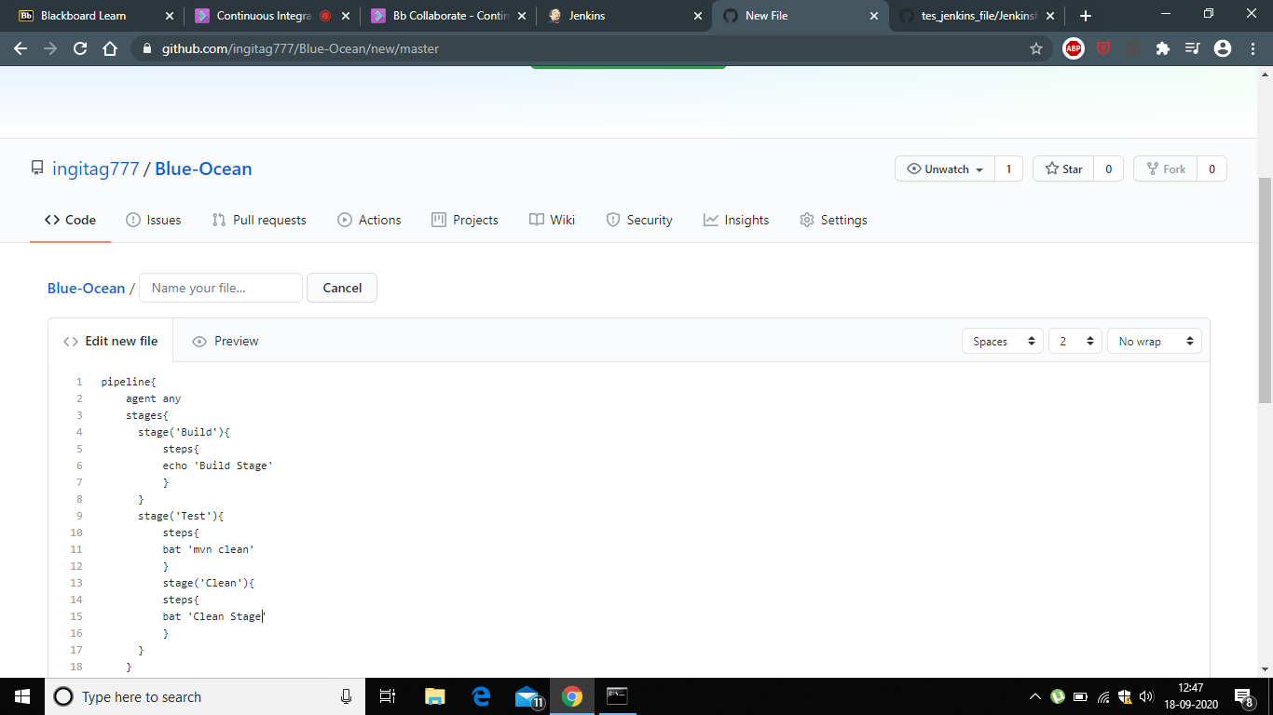

**4. Now come back to Blue Ocean screen and select your organization > Choose repository >Successfully Run the people.**

